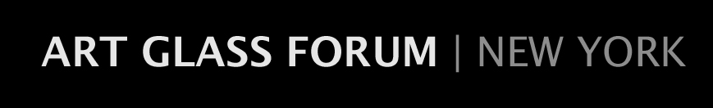
artglassforumny@gmail.com
MEMBERSHIP FORM
2020-2021 Season

Name________________________________________Occupation______________________

E-Mail address________________________________________________________________

Street_______________________________________Apt/Suite/Office No._________________

City______________________________________State______________Zip______________

Home Phone_________________Office Phone_________________ Cell__________________

Business Name (if applicable)____________________________________________________

Collecting Interests/Areas of Concentration__________________________________________

Please check the applicable category of membership:

☐ Young Professional (under 40) $25

☐ Individual $50

☐ Household $70

☐ Business/Corporate $100

Please make your check payable to The Art Glass Forum | NY and mail it, along with this completed form, to:

Ms. Arlie Sulka
220 East 57th Street
New York, NY 10022

I would like to make an additional tax-deductible contribution to the Art Glass Forum I NY in the amount of $____________. Any added contributions are greatly appreciated. Thank you.

