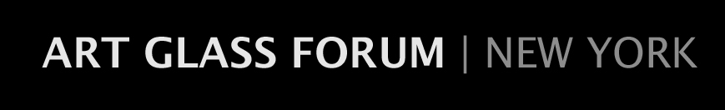
artglassforumny@gmail.com
MEMBERSHIP FORM
2016-2017 Season

Name________________________________________Occupation______________________

E-Mail address________________________________________________________________

Street_______________________________________Apt/Suite/Office No._________________

City______________________________________State______________Zip______________

Home Phone_________________Office Phone_________________ Cell__________________

Business Name (if applicable)____________________________________________________

Collecting Interests/Areas of Concentration__________________________________________

Please check the applicable category of membership:

☐ Young Professional $25

☐ Individual $70

☐ Household $90

Please make your check payable to The Art Glass Forum | NY and mail it, along with this completed form, to:

The Art Glass Forum | NY
c/o Amy McHugh
160 Summit Avenue
Apt. 32
Summit, NJ 07901

I would like to make an additional tax-deductible contribution to the Art Glass Forum I NY in the amount of $____________. Any added contributions are greatly appreciated.

Thank you.

