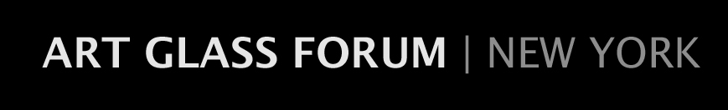
artglassforumny@gmail.com
MEMBERSHIP FORM
2018-2019 Season

Name________________________________________Occupation______________________

E-Mail address________________________________________________________________

Street_______________________________________Apt/Suite/Office No._________________

City______________________________________State______________Zip______________

Home Phone_________________Office Phone_________________ Cell__________________

Business Name (if applicable)____________________________________________________

Collecting Interests/Areas of Concentration__________________________________________

Please check the applicable category of membership:

☐ Young Professional $25

☐ Individual $70

☐ Household $90

☐ Business/Corporate $120

Please make your check payable to The Art Glass Forum | NY and mail it, along with this completed form, to:

The Art Glass Forum | NY
c/o Amy McHugh
13 Lewis Drive
Madison, NJ 07940

I would like to make an additional tax-deductible contribution to the Art Glass Forum I NY in the amount of $____________. Any added contributions are greatly appreciated. Thank you.

